Programming Exercise 6: Input Validation with Regular Expressions
Pedro Clavero De Dios
March 8, 2026
COP 2373

This program validates phone numbers, social security numbers, and zip codes using regular expressions. It includes a test suite that demonstrates validation with various valid and invalid inputs, and allows the user to enter their own values for validation.

Function: validate_phone_number
Validates a phone number using a regular expression. Accepts common US phone number formats including (xxx) xxx-xxxx, xxx-xxx-xxxx, xxx.xxx.xxxx, xxx xxx xxxx, and xxxxxxxxxx.
Parameters:
phone (str): The phone number string to validate.
Variables:
pattern (str): The regular expression pattern for valid phone numbers.
match (re.Match or None): The result of matching the phone string against the pattern.
Logic:
1. Define a regex pattern that accepts common US phone number formats.
2. Use re.fullmatch to check if the entire string matches the pattern.
3. Return True if there is a match, False otherwise.
Return:
bool: True if the phone number is valid, False otherwise.

Function: validate_ssn
Validates a social security number using a regular expression. Ensures the SSN follows the standard xxx-xx-xxxx format and does not start with 000, 666, or 900-999 per SSA rules.
Parameters:
ssn (str): The social security number string to validate.
Variables:
pattern (str): The regular expression pattern for valid SSNs.
match (re.Match or None): The result of matching the SSN string against the pattern.
Logic:
1. Define a regex pattern that matches the standard SSN format (xxx-xx-xxxx).
2. Ensure the SSN does not start with 000, 666, or 900-999 per SSA rules.
3. Use re.fullmatch to check if the entire string matches the pattern.
4. Return True if there is a match, False otherwise.
Return:
bool: True if the SSN is valid, False otherwise.

Function: validate_zip_code
Validates a zip code using a regular expression. Accepts both 5-digit and 9-digit (ZIP+4) formats.
Parameters:
zip_code (str): The zip code string to validate.
Variables:
pattern (str): The regular expression pattern for valid zip codes.
match (re.Match or None): The result of matching the zip code string against the pattern.
Logic:
1. Define a regex pattern that matches 5-digit or 9-digit (ZIP+4) zip codes.
2. Use re.fullmatch to check if the entire string matches the pattern.
3. Return True if there is a match, False otherwise.
Return:
bool: True if the zip code is valid, False otherwise.

Function: get_user_input
Prompts the user to enter a phone number, SSN, and zip code.
Parameters:
None
Variables:
phone (str): The phone number entered by the user.
ssn (str): The social security number entered by the user.
zip_code (str): The zip code entered by the user.
Logic:
1. Prompt the user to enter a phone number.
2. Prompt the user to enter a social security number.
3. Prompt the user to enter a zip code.
4. Return all three values as a tuple.
Return:
tuple: A tuple containing the phone number, SSN, and zip code strings.

Function: display_results
Validates and displays the results for each input.
Parameters:
phone (str): The phone number to validate and display.
ssn (str): The social security number to validate and display.
zip_code (str): The zip code to validate and display.
Variables:
phone_valid (bool): Whether the phone number is valid.
ssn_valid (bool): Whether the SSN is valid.
zip_valid (bool): Whether the zip code is valid.
Logic:
1. Validate the phone number using validate_phone_number.
2. Validate the SSN using validate_ssn.
3. Validate the zip code using validate_zip_code.
4. Display the validation results for each input.
Return:
None

Function: test_validations
Tests the validation functions with various valid and invalid inputs to ensure correctness.
Parameters:
None
Variables:
phone_tests (list): A list of tuples containing phone numbers and expected results.
ssn_tests (list): A list of tuples containing SSNs and expected results.
zip_tests (list): A list of tuples containing zip codes and expected results.
Logic:
1. Define test cases for phone numbers with valid and invalid examples.
2. Define test cases for SSNs with valid and invalid examples.
3. Define test cases for zip codes with valid and invalid examples.
4. Run each test and display the result compared to the expected value.
Return:
None

Function: main
Main function that runs the validation program.
Parameters:
None
Variables:
phone (str): The phone number entered by the user.
ssn (str): The social security number entered by the user.
zip_code (str): The zip code entered by the user.
continue_choice (str): The user's choice to continue or exit.
Logic:
1. Display a welcome message.
2. Run the test suite to demonstrate validation with various inputs.
3. Enter a loop to allow the user to validate their own inputs.
4. Get user input for phone number, SSN, and zip code.
5. Display validation results.
6. Ask if the user wants to validate more inputs.
7. Exit when the user chooses not to continue.
Return:
None

Screenshot:
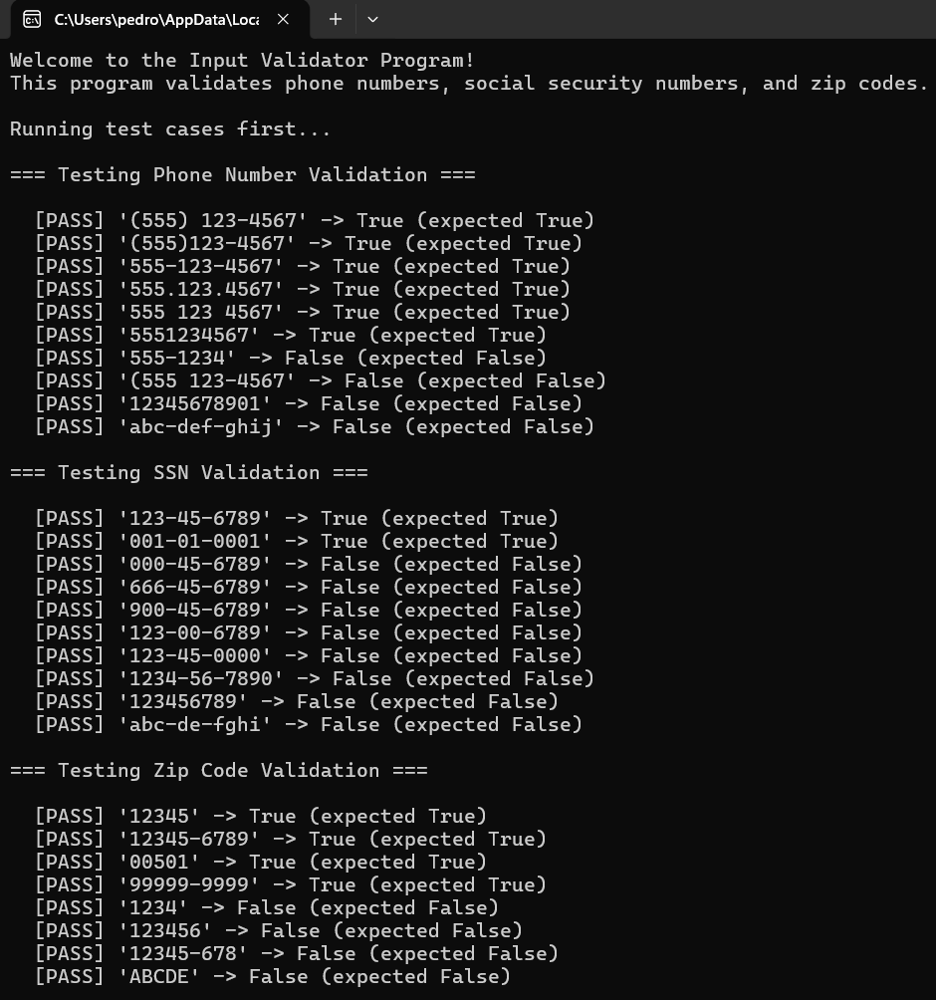
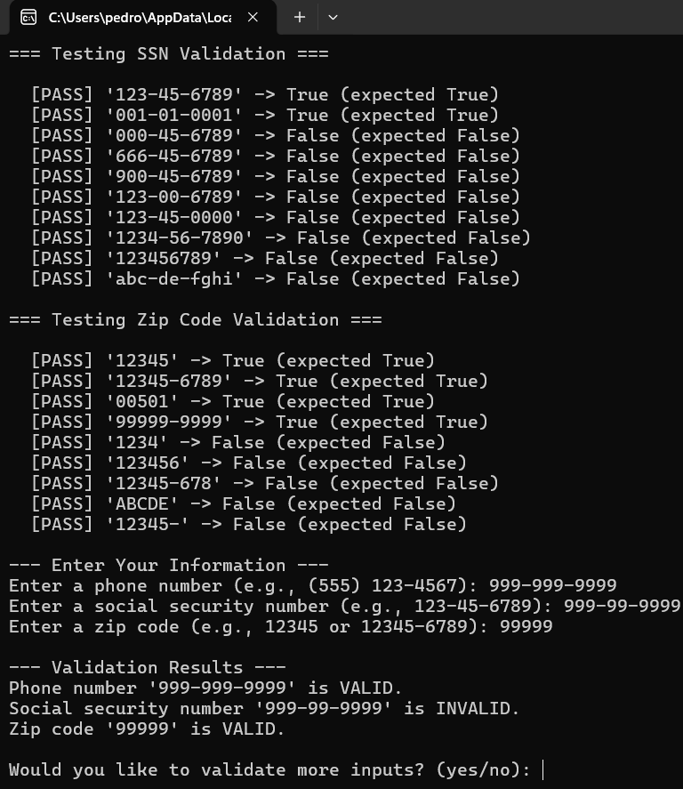
Repo
GitHub Repo Link: https://github.com/Pclav34/PC_COP2373

